THE SKY GEN
AI ENGINEER
PROMPT ENGINEERING TOOLKIT
A Tested Prompt Library for Python, Machine Learning & AI Development
PROJECT 01 — BEGINNER LEVEL
Prepared for: The Sky Gen
Profession: AI Engineer
Specialization: Python & Machine Learning
Program: September–November 2026
Executive Summary
This project develops a practical prompt library for an AI Engineer working primarily with Python and Machine Learning. The toolkit focuses on recurring engineering tasks including code generation, debugging, preprocessing, feature engineering, model selection, evaluation, error analysis, documentation, pipeline design and deployment planning. Each prompt is evaluated through a before-and-after test. A deliberately weak prompt establishes a baseline, while an improved prompt introduces explicit role, task, context, output format and constraints. The screenshots supplied by the author provide the actual model evidence for each test.
Project Objective
The objective is to demonstrate how precise instructions, relevant context, examples and structured constraints can improve the usefulness and consistency of AI-assisted engineering work.
Profession & Common Tasks
• Python code generation
• Python debugging
• Code explanation
• Data preprocessing
• Feature engineering
• Model selection
• Model evaluation
• Hyperparameter tuning
• ML error analysis
• Data-leakage detection
• SQL/data analysis
• Technical documentation
• ML pipeline design
• Deployment planning
• Technical project review
Prompt Design Framework
Every improved prompt in this toolkit follows a repeatable structure:
• ROLE — define the expertise and perspective required.
• TASK — state the exact objective.
• CONTEXT — provide the project situation and relevant background.
• INPUT — identify the information the model should use.
• OUTPUT FORMAT — define how the response must be organized.
• CONSTRAINTS — specify boundaries, assumptions, quality requirements and things the model must avoid.
Testing Methodology
For each prompt, the baseline version is tested first. The improved version is then tested using comparable information. The author captures the actual model outputs and inserts the screenshots into the marked spaces.
Prompt 01 — Python Code Generation
Generate a reproducible machine-learning training pipeline from a dataset specification.
Weak Prompt
Write a python code for machine learning model.
Improved Structured Prompt
ROLE: Act as a senior Python and machine-learning engineer. TASK: Create a Python training pipeline for a binary classification problem. CONTEXT: The dataset is a customer churn dataset containing numerical and categorical features. The target column is "churn". Missing values may exist in both numerical and categorical columns. INPUT: Dataset schema: - customer_age: numerical - monthly_charges: numerical - contract_type: categorical - tenure_months: numerical - support_tickets: numerical - payment_method: categorical - churn: binary target - Rows: approximately 5,000 OUTPUT FORMAT: 1. Brief approach 2. Complete Python code 3. Explanation of preprocessing 4. Evaluation strategy 5. Assumptions CONSTRAINTS: - Use scikit-learn. - Use Pipeline and ColumnTransformer where appropriate. - Avoid data leakage. - Use a reproducible random_state. - Keep the implementation modular. - Do not invent dataset columns that are not provided.
Before  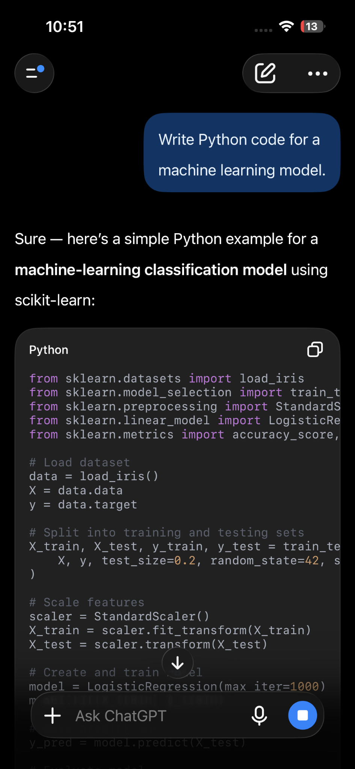 | After  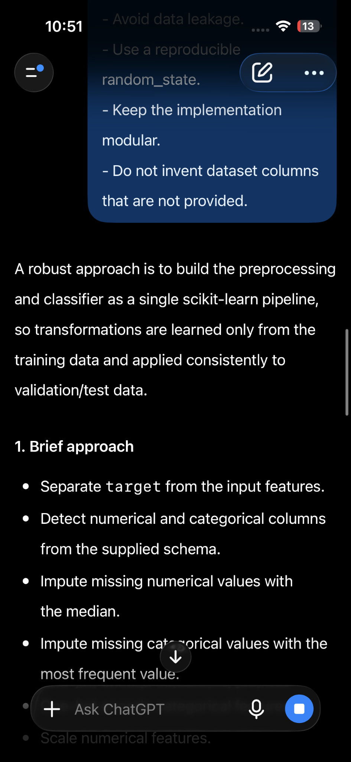
Comparison & Improvement Analysis
The improved prompt supplies task context, dataset assumptions, implementation requirements, output structure and engineering constraints. This makes the requested result more specific, easier to inspect and less dependent on unstated assumptions.
Prompt 02 — Python Debugging
Diagnose and correct Python code using both the code and its observed error.
Weak Prompt
Fix this python code
Improved Structured Prompt
ROLE: Act as a senior Python debugging engineer TASK: Diagnose and correct the following Python code. CONTEXT: The code is part of a machine-learning preprocessing workflow. CODE: [import pandas as pd df = pd.read_csv("customers.csv")df["age"] = df["age"].fillna(df["age"].median()) print(df["customer_name"])] ERROR: [KeyError: 'customer_name'] OUTPUT FORMAT: 1. Root cause of the error 2. Exact problematic section 3. Corrected code 4. Explanation of why the correction works 5. Prevention strategy CONSTRAINTS: - Do not rewrite unrelated sections. - Preserve the intended functionality. - Do not hide the problem with broad exception handling. - Clearly state any assumptions. - If the provided information is insufficient, identify what is missing instead of guessing.
Before   | After  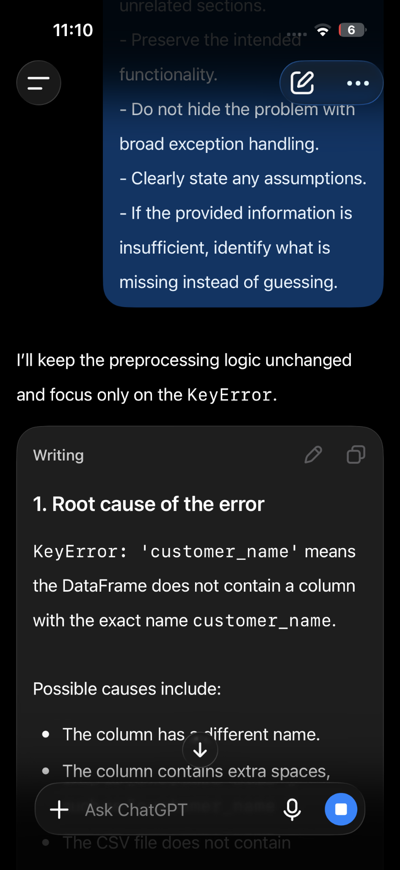
Comparison & Improvement Analysis
The improved version separates diagnosis from correction and requires the model to explain the root cause. It also prevents unrelated rewrites and encourages explicit handling of missing information.
Prompt 03 — Explain ML Code
Explain production-oriented ML code to a Python developer who is still developing practical ML experience.
Weak Prompt
Explain this machine learning code.
Improved Structured Prompt
ROLE: Act as an experienced machine-learning mentor. TASK: Explain the supplied Python machine-learning code to a Python developer who is developing their ML knowledge. CODE: import pandas as pd from sklearn.model_selection import train_test_split from sklearn.preprocessing import StandardScaler from sklearn.linear_model import LogisticRegression from sklearn.metrics import accuracy_score df = pd.read_csv("customers.csv") X = df[[ "customer_age", "monthly_charges","tenure_months"]]y = df["churn"] X_train, X_test, y_train, y_test = train_test_split(X,y, test_size=0.2, random_state=42) scaler = StandardScaler() X_train = scaler.fit_transform(X_train) X_test = scaler.transform(X_test) model = LogisticRegression() model.fit(X_train, y_train) predictions = model.predict(X_test) accuracy = accuracy_score(y_test, predictions) print("Model Accuracy:", accuracy) OUTPUT FORMAT: 1. Overall purpose 2. Step-by-step explanation 3. Important machine-learning concepts used 4. Input and output flow 5. Potential problems or risks 6. Short summary CONSTRAINTS: - Explain important technical terms. - Do not skip important sections of the code. - Distinguish between what the code actually does and what it may have been intended to do.- Do not invent functionality that is not present in the code.
Before   | After  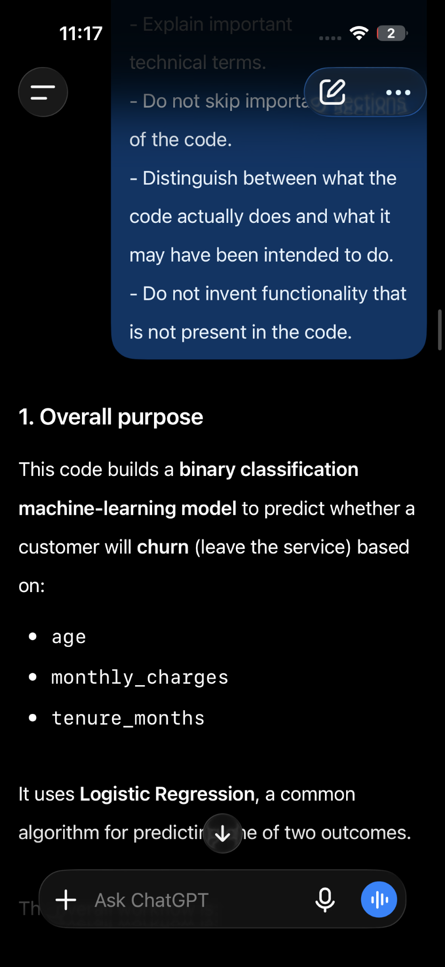
Comparison & Improvement Analysis
The improved prompt defines the audience, requested explanation structure and an important distinction between actual behavior and intended behavior. This reduces vague or overly generic explanations.
Prompt 04 — Data Preprocessing
Design a preprocessing strategy while explicitly protecting the workflow from data leakage.
Weak Prompt
Preprocess this dataset for machine learning
Improved Structured Prompt
ROLE: Act as a senior machine-learning engineer specializing in data preprocessing. TASK: Design an appropriate preprocessing strategy for the dataset below. CONTEXT: The goal is to prepare a customer churn dataset for a binary classification model. DATASET: Dataset: Customer Churn Dataset Rows: approximately 5,000 Columns: customer_age Type: numerical Example: 35 monthly_charges Type: numerical Example: 79.50 contract_type Type: categorical Possible values: Month-to-month, One-year, Two-year tenure_months Type: numerical Example: 8 support_tickets Type: numerical Example: 4 payment_method Type: categorical Possible values: Electronic, Bank transfer, Credit card, Mailed check churn Type: binary target 0 = Did not churn 1 = Churned Missing values may exist in both numerical and categorical columns. OUTPUT FORMAT: 1. Data-quality checks 2. Missing-value strategy 3. Categorical-feature treatment 4. Numerical-feature treatment 5. Train/test preprocessing strategy 6. Recommended scikit-learn implementation 7. Reasoning behind each decision CONSTRAINTS: - Prevent data leakage. - Fit transformations using training data only. - Do not assume unnecessary preprocessing. - Explain assumptions. - Do not use the target column as an input feature.
Before  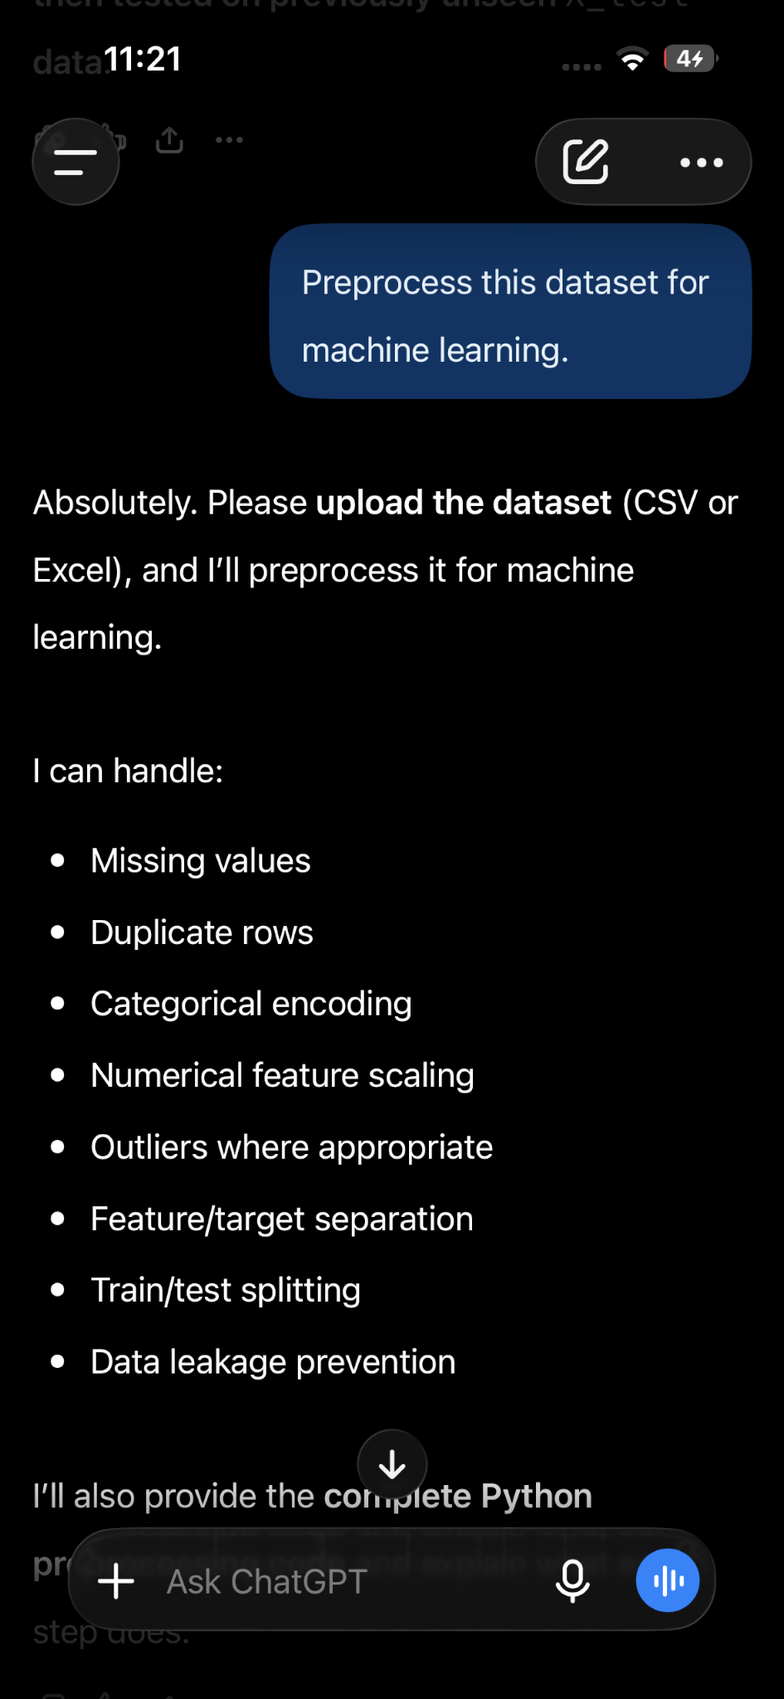 | After  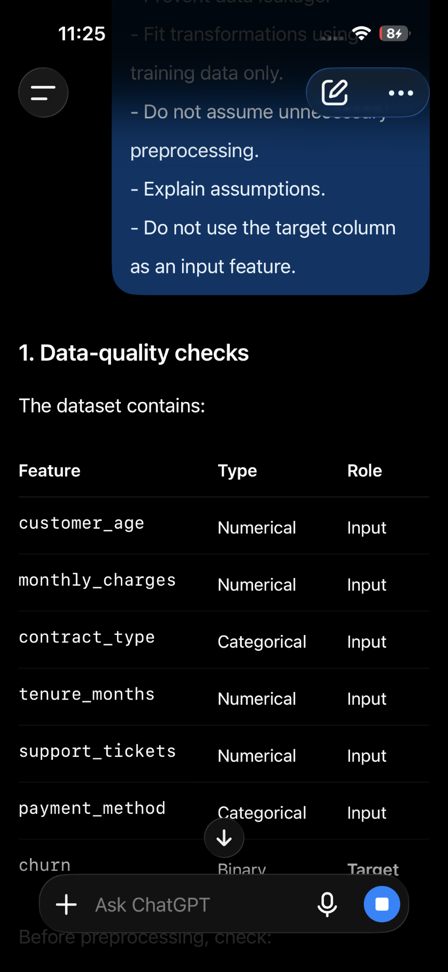
Comparison & Improvement Analysis
The improved version identifies the target, requests specific preprocessing categories and makes leakage prevention an explicit constraint. It also asks the model to justify rather than blindly apply transformations.
Prompt 05 — Feature Engineering
Identify candidate features while checking whether they would be available at prediction time.
Weak Prompt
Suggest some features for my dataset
Improved Structured Prompt
ROLE: Act as a machine-learning feature-engineering specialist. TASK: Identify potentially useful features that could improve a customer-churn classification model. CONTEXT: The dataset is a customer churn dataset. The goal is to predict whether a customer will churn using information available at prediction time. DATASET: Dataset: Customer Churn Dataset Rows: approximately 5,000 Available columns: customer_age monthly_charges contract_type tenure_months support_tickets payment_method churn Target: churn Target values: 0 = Did not churn 1 = Churned Prediction goal: Predict whether a customer will churn using information available at prediction time. OUTPUT FORMAT | Feature | Source Columns | Transformation | Expected Usefulness | Risk | After the table, provide: 1. Top candidate features 2. Reasoning behind each candidate 3. Validation approach CONSTRAINTS: - Do not use the target column to create features. - Avoid target leakage. - Do not use information that would be unavailable when making a real prediction. - Clearly distinguish evidence-based observations from hypotheses. - Do not invent additional source columns. - Explain any assumptions you make.
Before  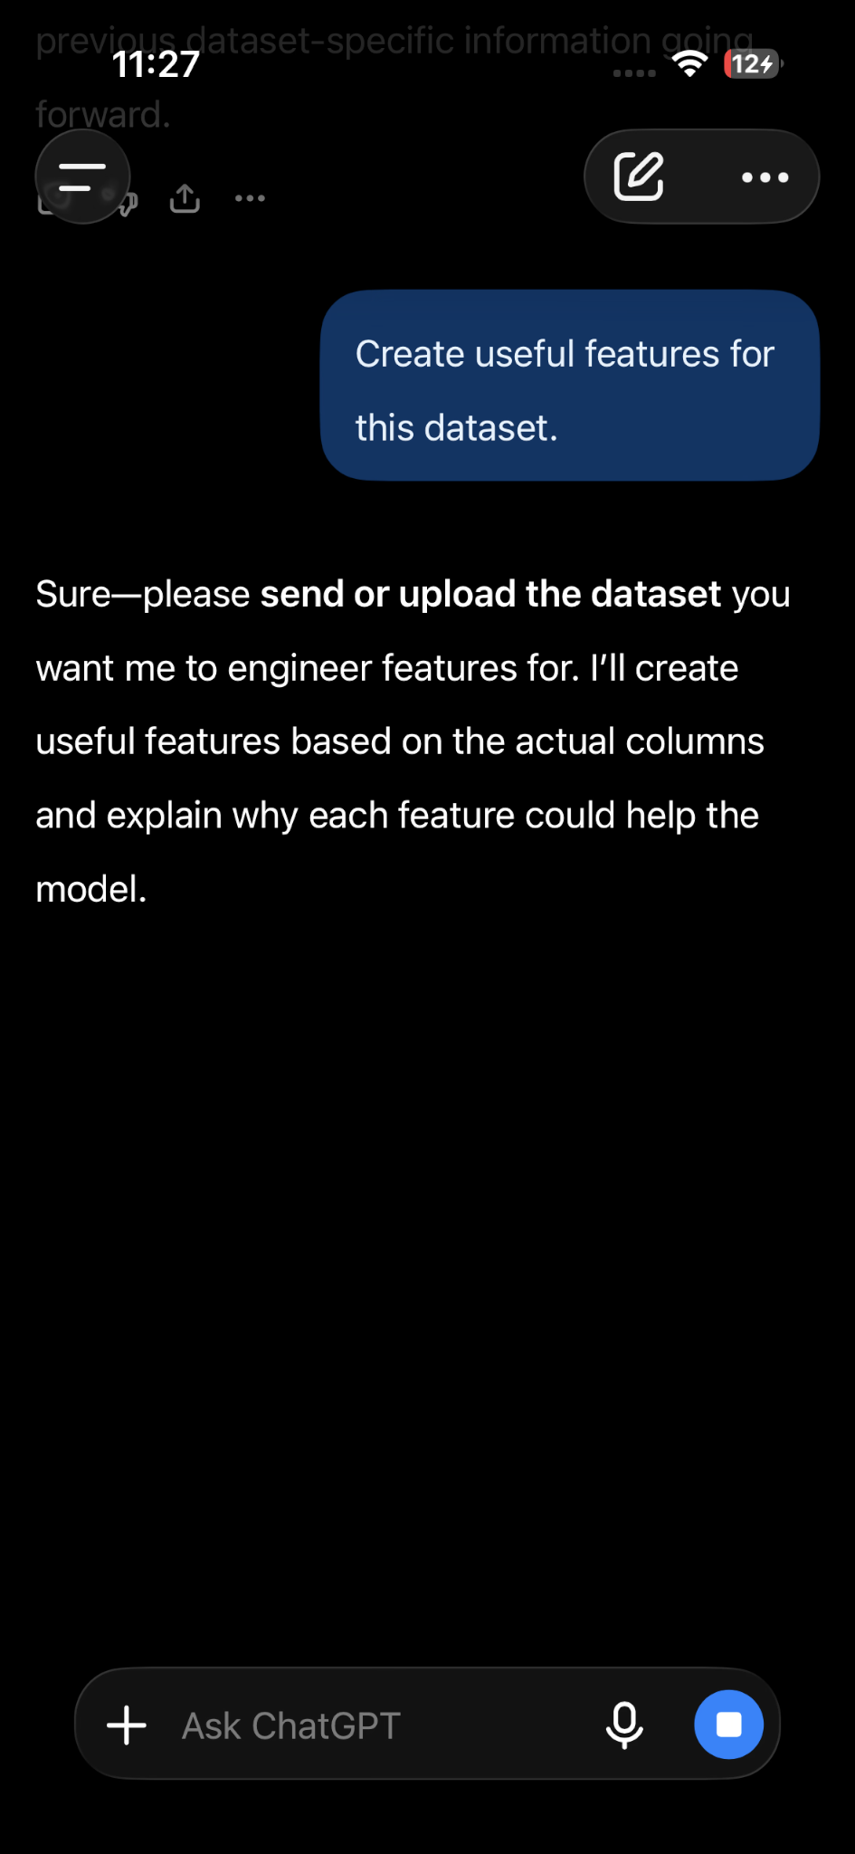 | After  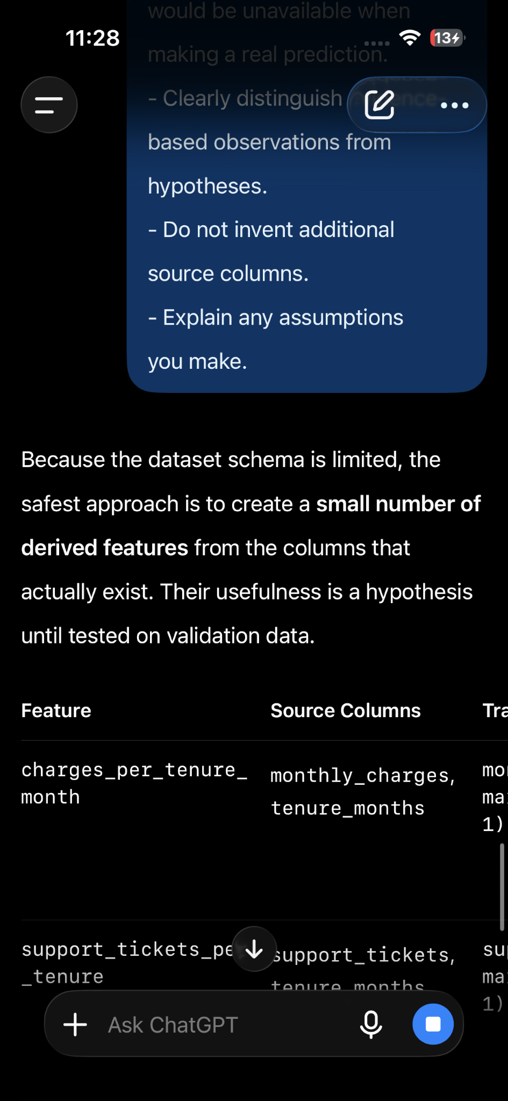
Comparison & Improvement Analysis
The table format makes the recommendations easier to review. The constraints also focus attention on leakage and on the difference between evidence and hypotheses.
Prompt 06 — Model Selection
Compare candidate algorithms based on the actual problem and dataset characteristics.
Weak Prompt
Which machine learning model should I use?
Improved Structured Prompt
ROLE: Act as a machine-learning model-selection specialist. TASK: Recommend suitable candidate models for a binary customer-churn classification problem. CONTEXT: We want to predict whether a customer will churn. The dataset contains approximately 5,000 customer records. The features include both numerical and categorical variables. Missing values may exist. DATASET: - customer_age: numerical - monthly_charges: numerical - contract_type: categorical - tenure_months: numerical - support_tickets: numerical - payment_method: categorical - churn: binary target TARGET: churn 0 = Did not churn 1 = Churned REQUIREMENTS: The models should be suitable for a Python and scikit-learn workflow. OUTPUT FORMAT: Create a comparison table with: | Model | Why Consider It | Strengths | Weaknesses | Computational Considerations | Then provide: 1. Recommended candidate models2. Suggested evaluation strategy 3. Factors that should influence the final selection 4. Assumptions CONSTRAINTS: - Include at least three reasonable candidate models. - Do not declare one model universally best. - Consider the dataset size and mixed feature types. - Explain why each model is appropriate. - Clearly separate evidence from assumptions.
Before  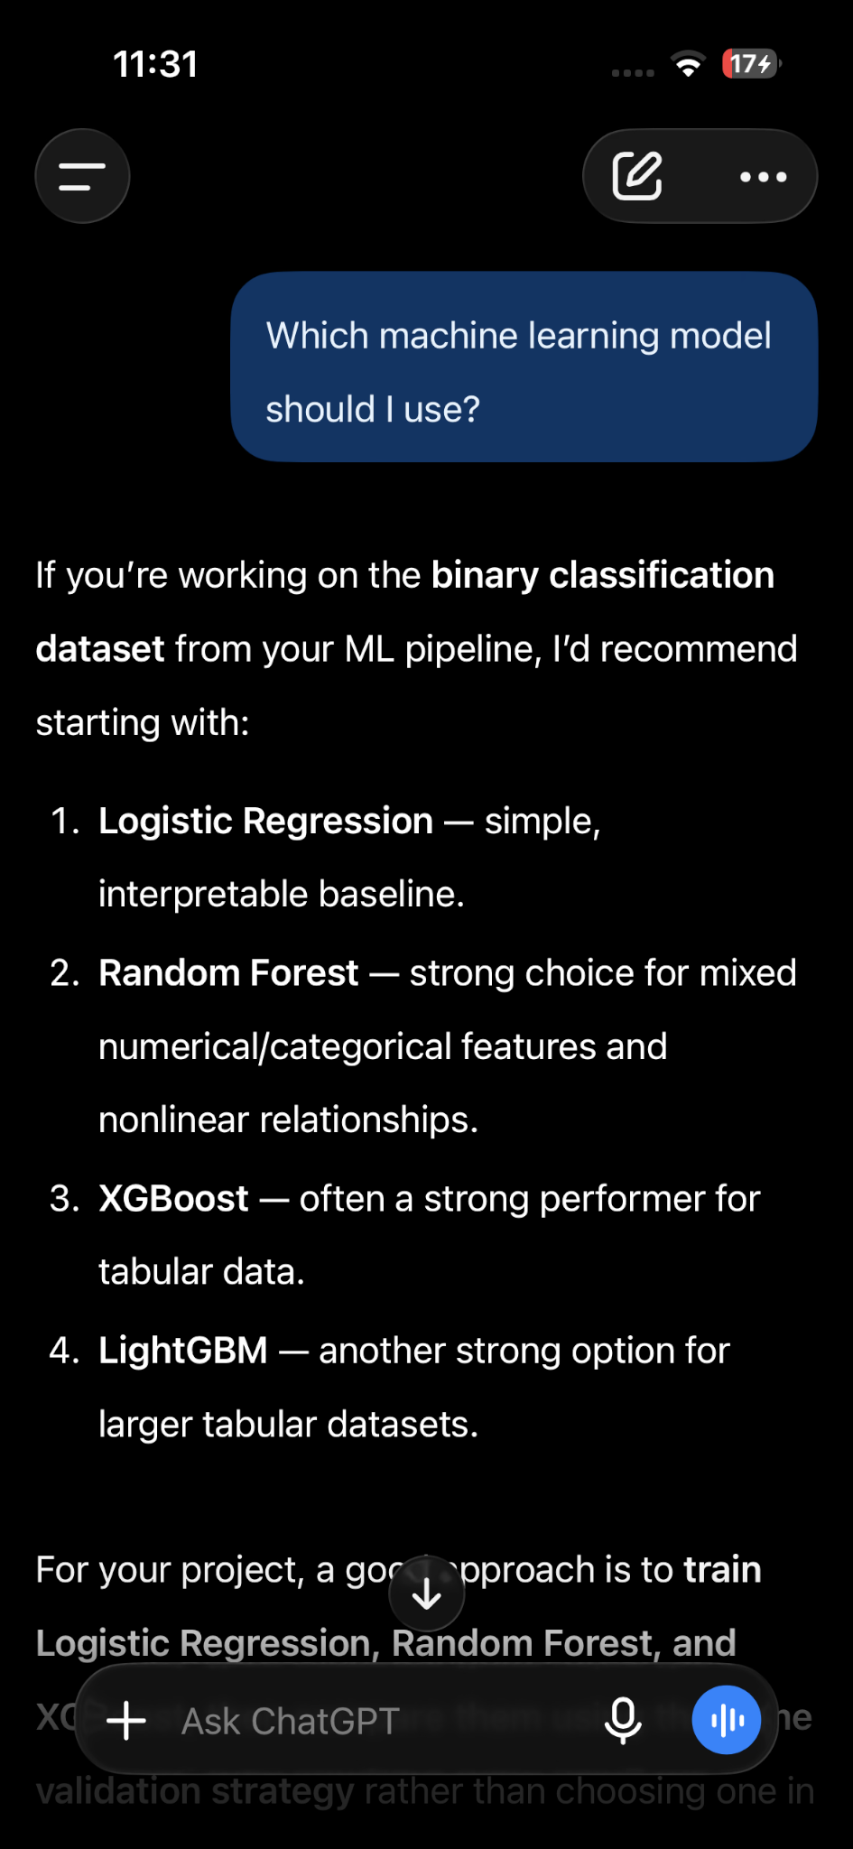 | After  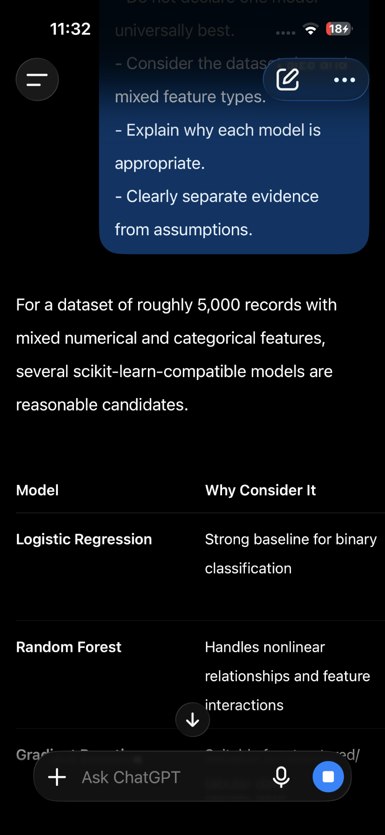
Comparison & Improvement Analysis
The improved prompt replaces an unsupported request for a universal 'best' model with a comparative engineering analysis tied to dataset characteristics and experiments.
Prompt 07 — Model Evaluation
Choose evaluation metrics and an evaluation strategy appropriate to the actual ML problem.
Weak Prompt
How should I evaluate my machine learning model?
Improved Structured Prompt
ROLE: Act as a machine-learning model-evaluation specialist. TASK: Design an evaluation strategy for a binary customer-churn classification model. CONTEXT: The model predicts whether a customer will churn. The dataset contains approximately 5,000 observations. The target is binary, and the classes may not be perfectly balanced. DATASET: - customer_age: numerical - monthly_charges: numerical - contract_type: categorical - tenure_months: numerical - support_tickets: numerical - payment_method: categorical - churn: binary target TARGET: churn 0 = Did not churn 1 = Churned MODEL: A Logistic Regression classifier trained using scikit-learn. OUTPUT FORMAT: 1. Primary evaluation metrics 2. Secondary metrics 3. Validation strategy 4. What each metric reveals 5. How to interpret the results 6. Common evaluation mistakes 7. Example Python evaluation code CONSTRAINTS: - Do not rely on accuracy alone. - Explain why each recommended metric is useful. - Separate validation data from the final test set. - Explain how class imbalance could affect interpretation. - Do not assume the business cost of false positives and false negatives without stating the assumption.
Before  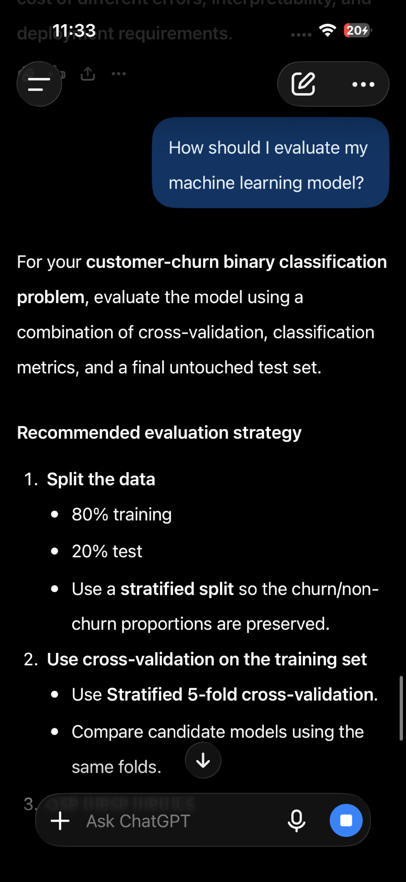 | After  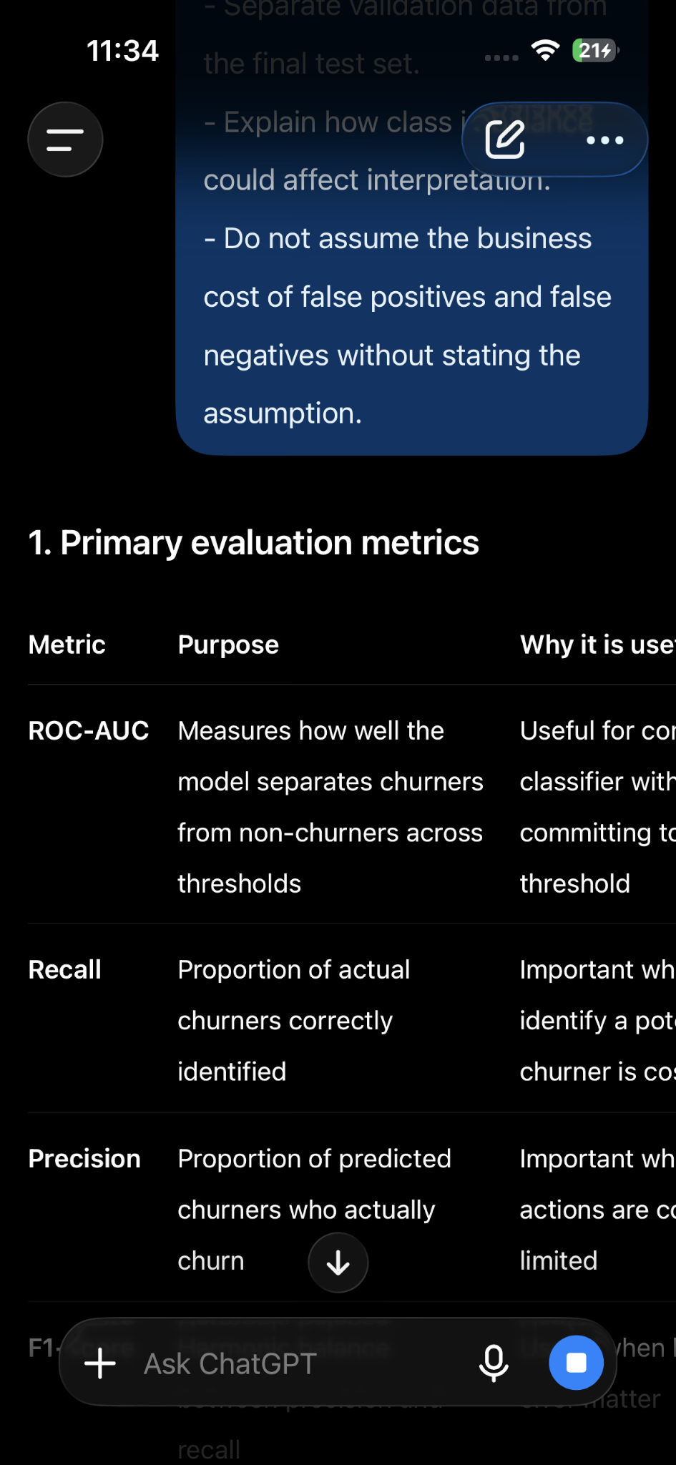
Comparison & Improvement Analysis
The improved prompt provides the information needed to select meaningful metrics and explicitly prevents an automatic accuracy-first recommendation.
Prompt 08 — Hyperparameter Tuning
Create a reproducible tuning strategy without contaminating the final test set.
Weak Prompt
Tune my machine learning model to get the best results.
Improved Structured Prompt
ROLE: Act as a senior machine-learning experimentation engineer. TASK: Design a reproducible hyperparameter-tuning strategy for a Random Forest binary classification mod CONTEXT: The dataset contains approximately 5,000 customer records with numerical and categorical features. DATASET: - customer_age: numerical - monthly_charges: numerical - contract_type: categorical - tenure_months: numerical - support_tickets: numerical - payment_method: categorical - churn: binary target TARGET: churn 0 = Did not churn 1 = Churned MODEL: RandomForestClassifier from scikit-learn. OUTPUT FORMAT: 1. Hyperparameters to tune 2. Reasonable search ranges 3. Search method 4. Cross-validation strategy 5. Scoring metric 6. Reproducibility settings 7. Complete Python example 8. Final-test procedure CONSTRAINTS: - Do not use the final test set for hyperparameter tuning. - Explain why each parameter is being tuned. - Keep the search computationally realistic for approximately 5,000 rows. - Use reproducible settings. - Clearly distinguish cross-validation performance from final test performance.
Before  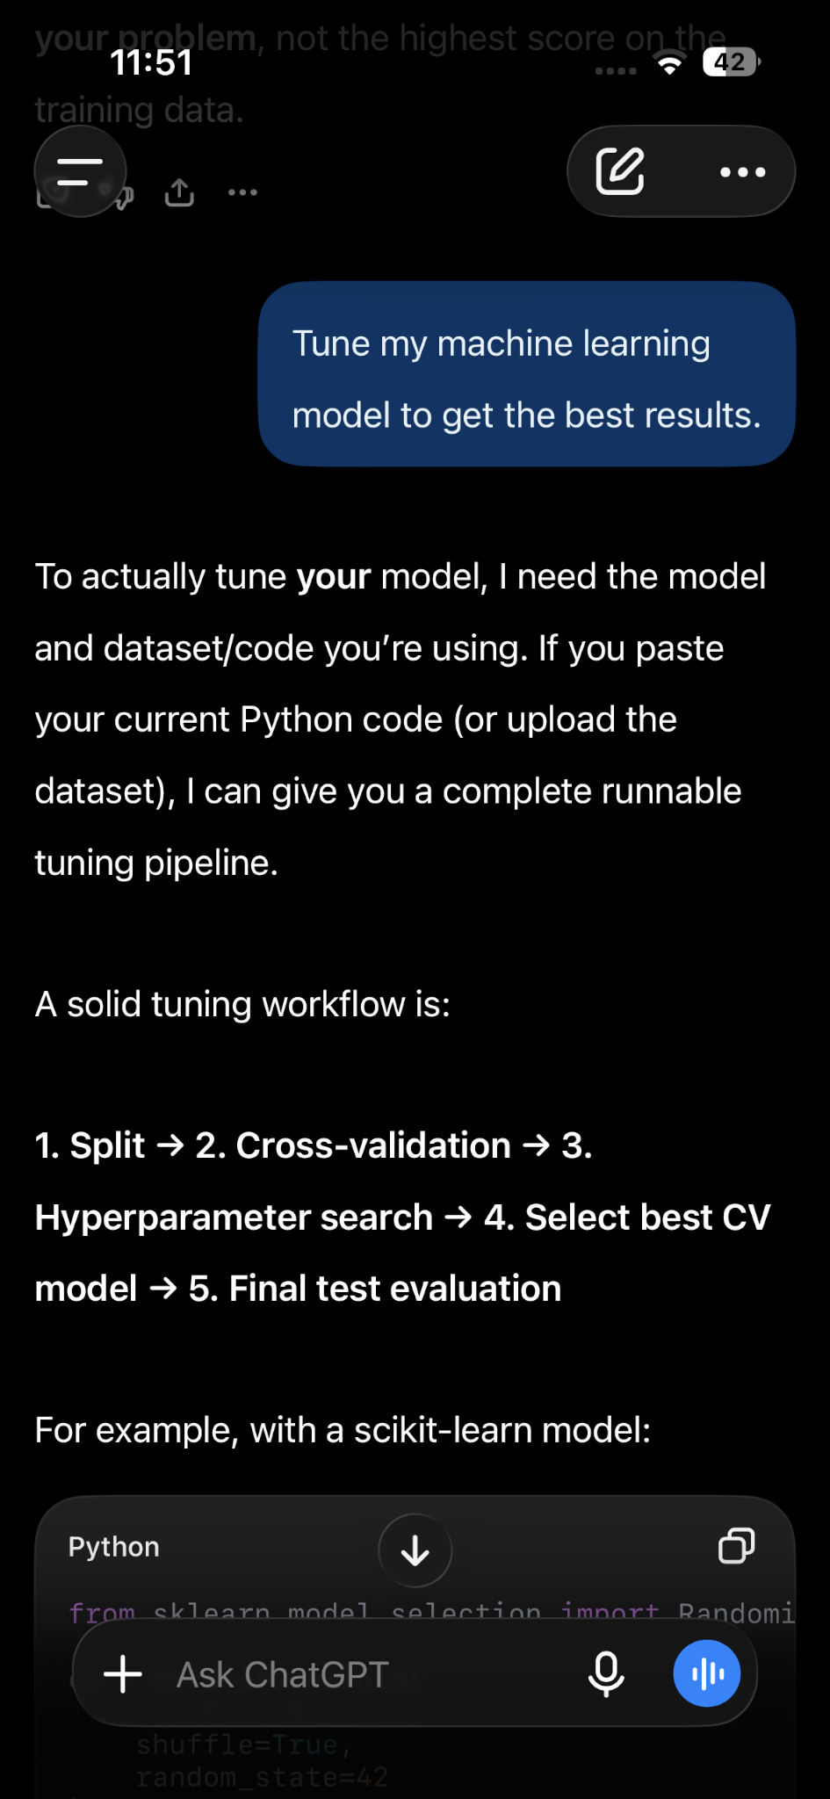 | After  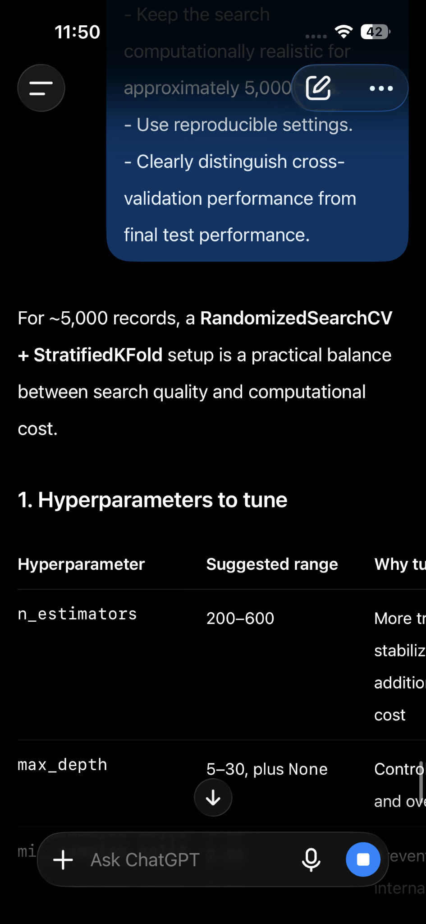
Comparison & Improvement Analysis
The improved prompt makes experimental boundaries explicit. It separates tuning from final testing and asks for reproducibility and computational considerations.
Prompt 09 — ML Error Analysis
Analyze prediction errors and identify patterns that can guide further investigation.
Weak Prompt
Analyze my model error.
Improved Structured Prompt
ROLE: Act as a machine-learning error-analysis specialist. TASK: Analyze the prediction errors made by a customer-churn classification model and identify patterns that deserve further investigation. CONTEXT: The model predicts whether a customer will churn. DATASET: - customer_age: numerical - monthly_charges: numerical - contract_type: categorical - tenure_months: numerical - support_tickets: numerical - payment_method: categorical - churn: binary target TARGET: churn 0 = Did not churn 1 = Churned MODEL PREDICTIONS: | Customer | Actual | Predicted | Confidence |Contract Type | Monthly Charges | Tenure Months | Support Tickets | |---|---:|---:|---:|---|---:|---:|---:|| C001 | 1 | 0 | 0.91 | Month-to-month | 85 | 4 | 6 || C002 | 0 | 1 | 0.62 | One-year | 55 | 24 | 1 || C003 | 1 | 1 | 0.88 | Month-to-month | 92 | 3 | 7 || C004 | 0 | 1 | 0.79 | Two-year | 48 | 36 | 0 || C005 | 1 | 0 | 0.87 | Month-to-month | 78 | 6 | 5 || C006 | 0 | 0 | 0.94 | Two-year | 45 | 40 | 1 | OUTPUT FORMAT: Create a table: | Error ID | Error Type | Observed Pattern | Evidence | Suggested Investigation | Then provide: 1. Most important observations 2. High-confidence incorrect predictions 3. Possible hypotheses 4. Recommended next investigations CONSTRAINTS: - Do not claim causation from this small sample. - Clearly separate observations from hypotheses. - Highlight high-confidence incorrect predictions. - Do not claim statistical significance. - Use only information provided in the table.
Before  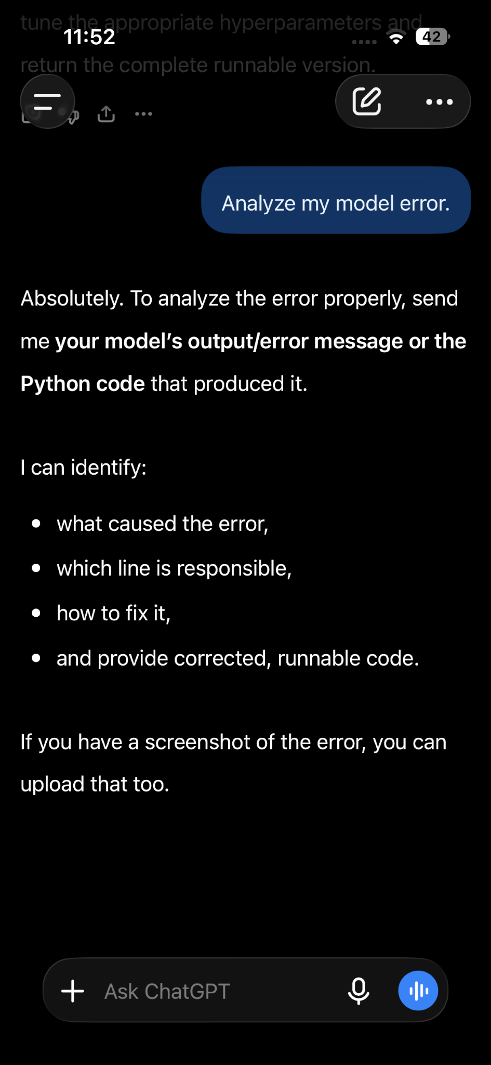 | After  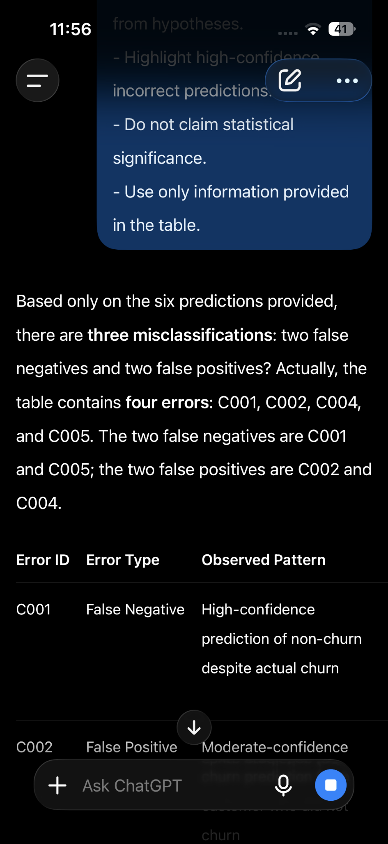
Comparison & Improvement Analysis
The improved prompt creates a consistent error-analysis record and explicitly separates evidence from hypotheses, reducing unsupported causal claims.
Prompt 10 — Data Leakage Detection
Review an ML workflow for possible sources of training/test contamination.
Weak Prompt
Check if the machine learning flow have data leakage.
Improved Structured Prompt ROLE: Act as a machine-learning validation reviewer. TASK: Audit the following machine-learning workflow for potential data leakage. CONTEXT: The workflow predicts customer churn using Python and scikit-learn. DATASET: The dataset contains these numerical features: - customer_age - monthly_charges - tenure_months - support_tickets TARGET: churn 0 = Did not churn 1 = Churned WORKFLOW CODE: import pandas as pd from sklearn.model_selection import train_test_split from sklearn.preprocessing import StandardScaler from sklearn.linear_model import LogisticRegression df = pd.read_csv("customers.csv") X = df[[ "customer_age","monthly_charges","tenure_months", "support_tickets"] ]y = df["churn"] # Preprocessing is performed before the train/test split scaler = StandardScaler() X_scaled = scaler.fit_transform(X) # Train/test split X_train, X_test, y_train, y_test = train_test_split( X_scaled, y, test_size=0.2,random_state=42) # Train model model = LogisticRegression() model.fit(X_train, y_train) predictions = model.predict(X_test) OUTPUT FORMAT: Create a table: | Potential Leakage Point | Why It Could Leak Information | Severity | Safer Alternative | Verification Step | Then provide: 1. Overall assessment 2. Explanation of each potential issue 3. Corrected workflow 4. Verification checklist CONSTRAINTS: - Check the train/test split. - Check preprocessing. - Check feature engineering. - Check validation. - Check target-derived information. - Explain the mechanism of suspected leakage. - Do not label something as leakage without explaining why. - Clearly identify uncertainty.
Before  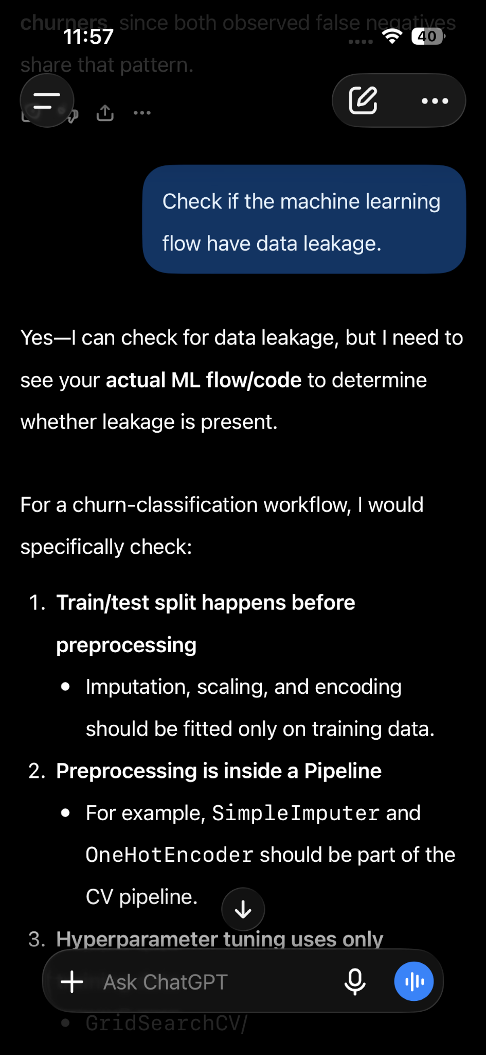 | After  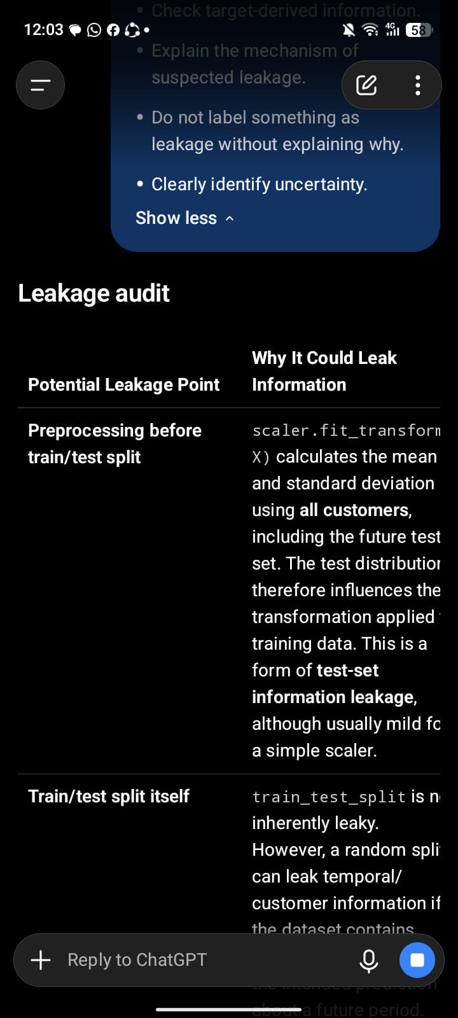
Comparison & Improvement Analysis
The improved prompt gives the reviewer a systematic audit structure and specifies where leakage should be checked. It also requires the mechanism and verification step to be explained.
Prompt 11 — SQL / Data Analysis
Generate SQL from a supplied schema and analytical requirement while avoiding invented fields.
Weak Prompt
Write SQL to analyze my data
Improved prompt
ROLE: Act as a senior SQL data analyst. TASK: Write complete, runnable SQL to clean, validate, and analyze a customer-churn dataset. DATABASE TABLE:
customer_churn SCHEMA: customer_id INTEGER customer_age INTEGER contract_type VARCHAR monthly_charges DECIMAL(10,2)tenure_months INTEGER support_tickets INTEGER payment_method VARCHAR M churn INTEGERsignup_date DATE TARGET: churn is the binary target: 0 = retained 1 = churned REQUIREMENTS: DATA QUALITY CHECKS
Write SQL to: Count total rows. Check for NULL values in every column. Detect duplicate customer_id values. Check for invalid churn values other than 0 or 1.Check for invalid or negative customer_age values. Check for invalid or negative monthly_charges. Check for invalid or negative tenure_months. Check for invalid or negative support_tickets. Check for invalid signup_date values where supported by the SQL dialect. DATA CLEANING
Provide SQL approaches for: Handling NULL values. Removing or identifying duplicate customer records. Handling invalid numeric values. Standardizing categorical values such as contract_type and payment_method. Do not silently delete records. Clearly show which records would be affected before providing any DELETE or UPDATE statement. CUSTOMER-CHURN ANALYSIS
Write SQL to calculate:Total customers. Churned customers. Retained customers. Overall churn rate. Churn rate by contract_type. Churn rate by payment_method. Churn rate by tenure group. Churn rate by support-ticket group. Average monthly_charges for churned versus retained customers. Average tenure_months for churned versus retained customers.Monthly customer signups using signup_date.OUTLIER / ANOMALY CHECKS Write SQL queries to identify potentially unusual values in: monthly_chargestenure_months support_tickets customer_age Do not automatically remove outliers. Flag them for review.OUTPUT FORMAT Provide: SQL dialect assumption. Data-quality queries. Data-cleaning queries. Exploratory-analysis queries. Anomaly-detection queries.Brief explanation of each query. Important assumptions and limitations. CONSTRAINTS:Use only the supplied table and column names. Make the SQL runnable for the stated SQL dialect.Do not invent additional columns. Do not modify data unless explicitly requested. Clearly separate SELECT-based validation from UPDATE/DELETE operations. Handle NULL values appropriately. Do not claim that correlation proves causation. Do not use churn as an input feature in predictive analysis.If a SQL operation differs between PostgreSQL, MySQL, SQL Server, or SQLite, clearly identify the difference.
Before  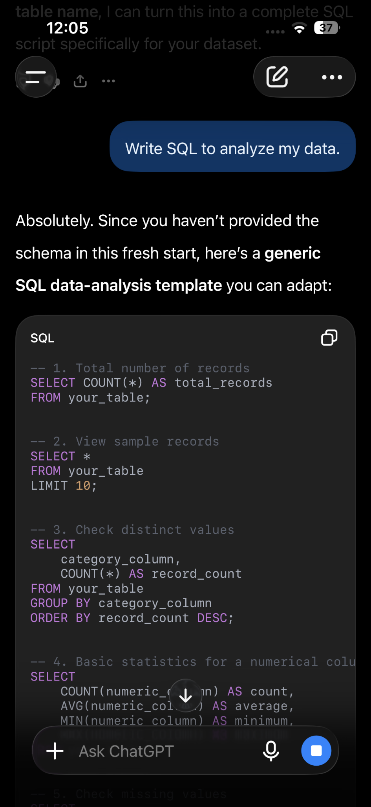 | After  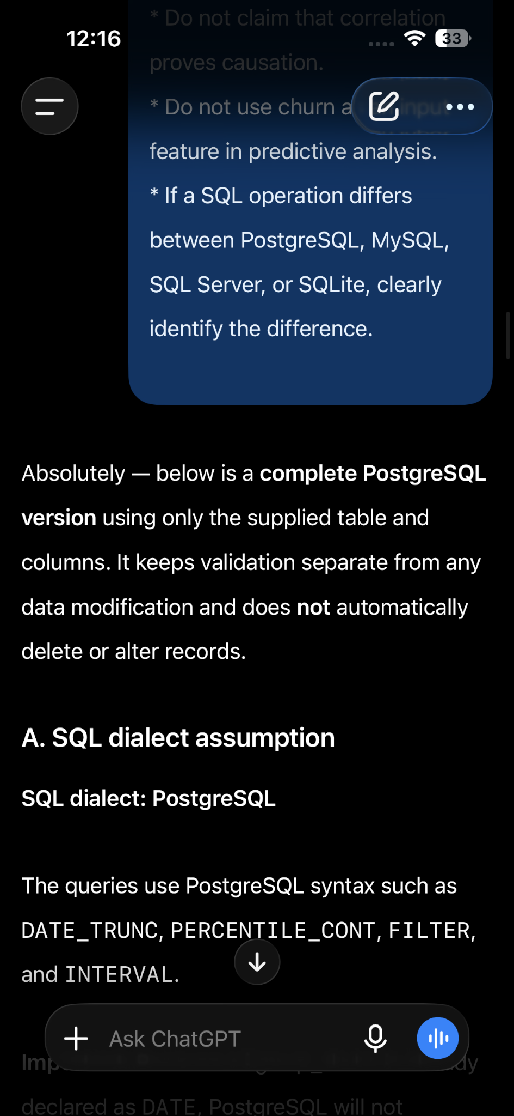
Comparison & Improvement Analysis
The improved version supplies schema, question, output requirements and validation concerns. It directly addresses a common failure mode: inventing columns or making hidden database assumptions.
Prompt 12 — Technical Documentation
Turn supplied engineering code into concise, maintainable technical documentation.
Weak Prompt
Document this code. import pandas as pd from sklearn.model_selection import train_test_split from sklearn.preprocessing import StandardScaler from sklearn.linear_model import LogisticRegression from sklearn.metrics import accuracy_score df=pd.read_csv("customers.csv")required_columns = ["customer_age","monthly_charges","tenure_months","churn"] missing_columns = [col for col in required_columns if col not in df.columns] if missing_columns:raise ValueError(f"Missing required columns:{missing_columns}") X = df[["customer_age","monthly_charges","tenure_months"]] y = df["churn"] X_train, X_test, y_train, y_test = train_test_split(X,y, test_size=0.2, random_state=42)scaler = StandardScaler() X_train_scaled = scaler.fit_transform(X_train) X_test_scaled = scaler.transform(X_test) model = LogisticRegression(random_state=42) model.fit(X_train_scaled, y_train) predictions = model.predict(X_test_scaled) accuracy = accuracy_score(y_test, predictions) print("Model Accuracy:", accuracy)
Improved Structured Prompt
ROLE: Act as a technical writer with professional Python and machine-learning engineering experience. TASK: Create technical documentation for the following customer-churn machine-learning project. CONTEXT: The project uses Python and scikit-learn to train a binary classification model that predicts whether a customer will churn. PROJECT CODE: import pandas as pd from sklearn.model_selection import train_test_split from sklearn.preprocessing import StandardScaler from sklearn.linear_model import LogisticRegression from sklearn.metrics import accuracy_score # 1. Load the dataset df = pd.read_csv("customers.csv") # 2. Check that required columns exist required_columns = ["customer_age", "monthly_charges", "tenure_months", "churn"] missing_columns = [col for col in required_columns if col not in df.columns] if missing_columns: raise ValueError( f"Missing required columns: {missing_columns}") # 3. Select features and target X = df[[ "customer_age", "monthly_charges", "tenure_months" ]] y = df["churn"] # 4. Split the data into training and testing sets X_train, X_test, y_train, y_test = train_test_split( X,y, test_size=0.2, random_state=42) # 5. Standardize the numerical features scaler = StandardScaler() X_train_scaled = scaler.fit_transform(X_train) X_test_scaled = scaler.transform(X_test) # 6. Create and train the Logistic Regression model model = LogisticRegression(random_state=42) model.fit(X_train_scaled, y_train) # 7. Make predictions predictions = model.predict(X_test_scaled) # 8. Evaluate the model accuracy = accuracy_score(y_test, predictions) print("Model Accuracy:", accuracy) AUDIENCE: Python developers and ML engineers who may need to understand or maintain this project. OUTPUT FORMAT: 1. Project purpose 2. Dataset and inputs 3. Target variable 4. Outputs 5. Workflow 6. Dependencies 7. Assumptions 8. Evaluation method 9. Error considerations 10. Usage instructions 11. Maintenance notes CONSTRAINTS: - Document only behavior shown in the supplied code. - Do not invent features, dependencies, APIs, or results. - Clearly identify missing information. - Use concise technical language. - Explain the purpose of each major stage.
Comparison & Improvement Analysis
The improved prompt defines the audience and documentation sections while explicitly preventing invented behavior. This makes the output more useful as engineering documentation.
Prompt 13 — ML Pipeline Architecture
Design a modular ML pipeline based on project requirements and operational constraints.
Weak Prompt
Design a ML pipeline for my project.
Improved Structured Prompt
ROLE: Act as a senior machine-learning systems engineer. TASK: Design a modular machine-learning pipeline architecture for a binary classification project. PROJECT CONTEXT: - Dataset: approximately 5,000 rows - Numerical and categorical features - Binary target - Python and scikit-learn - Need reproducible training and evaluation - Future deployment may be required OUTPUT FORMAT: 1. Architecture overview 2. Pipeline stages 3. Data flow 4. Train/validation/test separation 5. Model-training process 6. Monitoring considerations 7. Potential failure points 8. Suggested project structure CONSTRAINTS: - Keep training and inference processes clearly separated. - Include data validation considerations. - Avoid unnecessary infrastructure. - Do not assume a specific cloud provider. - State assumptions separately from confirmed requirements.
Before  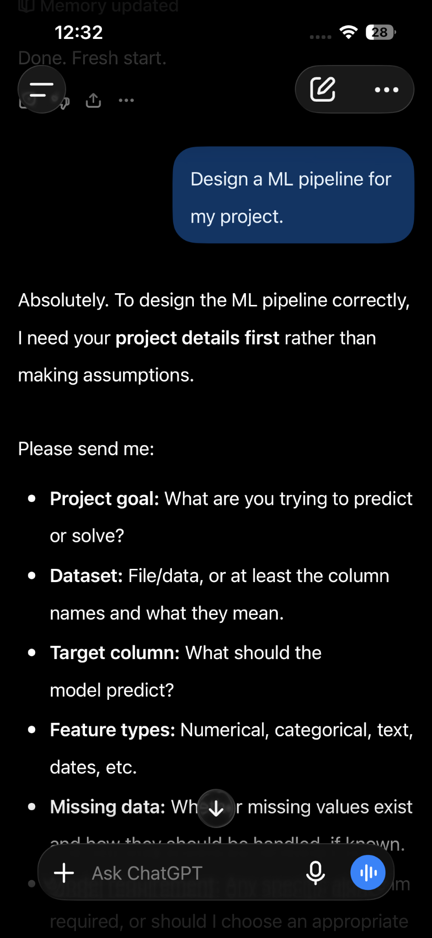 | After  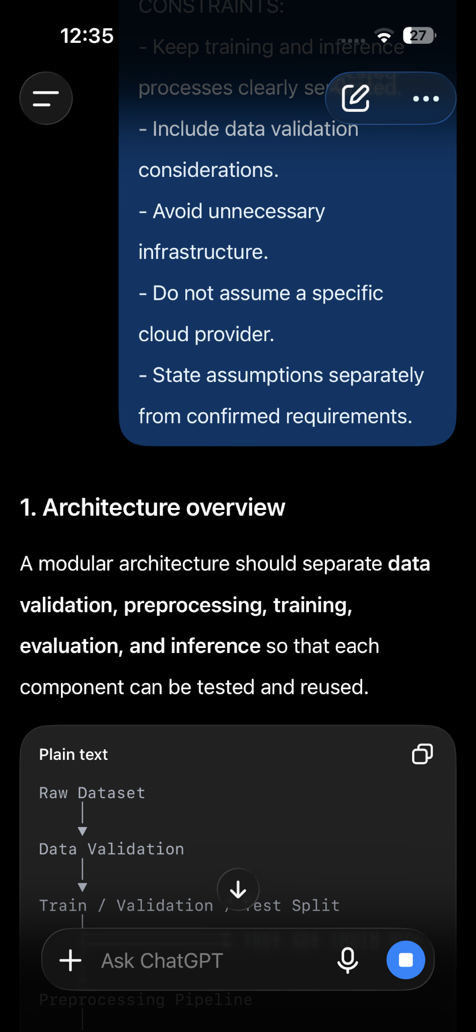
Comparison & Improvement Analysis
The improved prompt provides architecture-relevant context and forces separation of training, inference, validation and monitoring. It also keeps the proposed system proportional to the stated requirements.
Prompt 14 — Deployment Planning
Create a deployment plan for a trained ML model while identifying operational risks.
Weak Prompt
How can I deploy my machine learning model?
Improved Structured Prompt
ROLE: Act as an ML deployment engineer. TASK: Create a deployment plan for a customer-churn machine-learning model. CONTEXT: The model is a binary classification model built with Python and scikit-learn. It predicts whether a customer is likely to churn. DATASET: - customer_age: numerical - monthly_charges: numerical - contract_type: categorical - tenure_months: numerical - support_tickets: numerical - payment_method: categorical - churn: binary target MODEL: Logistic Regression with preprocessing. INPUT EXAMPLE: customer_age = 35 monthly_charges = 79.50 contract_type = "Month-to-month" tenure_months = 8 support_tickets = 4 payment_method = "Electronic" OUTPUT: A binary churn prediction. REQUIREMENTS: - Predictions should be reproducible. - The model and preprocessing steps must remain consistent. - The deployment environment has not yet been selected. - The system should support monitoring and model versioning. OUTPUT FORMAT: 1. Deployment architecture 2. Model packaging 3. API option 4. Batch-processing option 5. Input validation 6. Monitoring 7. Model versioning8. Data/version tracking 9. Rollback strategy 10. Testing checklist CONSTRAINTS: - Do not assume a specific cloud provider. - Separate confirmed requirements from recommendations. - Include security considerations. - Explain the difference between API and batch deployment. - Do not claim production readiness without sufficient information.
Before  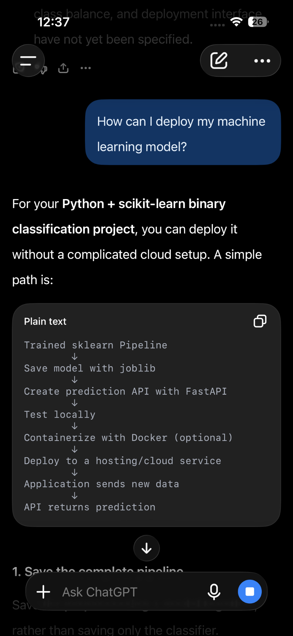 | After  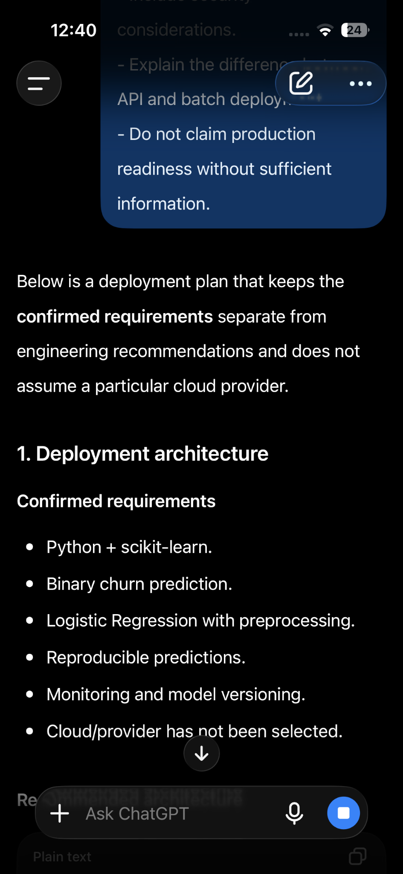
Comparison & Improvement Analysis
The improved prompt turns a broad deployment question into a concrete planning exercise and requires operational considerations such as monitoring, versioning, rollback and testing.
Prompt 15 — Technical Project Review
Conduct a structured review of a small AI/ML project and identify actionable improvements.
Weak Prompt
Correct my machine learning project
Improved Structured Prompt
ROLE: Act as a senior AI engineer conducting a technical project review. TASK: Review the supplied customer-churn machine-learning project and identify technical strengths, risks, and priority improvements. PROJECT OBJECTIVE: Build a binary classification model that predicts whether a customer will churn. DATASET: - customer_age: numerical - monthly_charges: numerical - contract_type: categorical - tenure_months: numerical - support_tickets: numerical - payment_method: categorical - churn: binary target PROJECT CODE: import pandas as pd from sklearn.model_selection import train_test_split from sklearn.preprocessing import StandardScaler from sklearn.linear_model import LogisticRegression from sklearn.metrics import accuracy_score df = pd.read_csv("customers.csv") X = df[["customer_age", "monthly_charges", "tenure_months"]] y = df["churn"] X_train, X_test, y_train, y_test = train_test_split( X, y, test_size=0.2, random_state=42 ) scaler = StandardScaler() X_train = scaler.fit_transform(X_train) X_test = scaler.transform(X_test) model = LogisticRegression() model.fit(X_train, y_train) predictions = model.predict(X_test) accuracy = accuracy_score(y_test, predictions) print("Model Accuracy:", accuracy) OUTPUT FORMAT: 1. Project summary 2. Technical strengths 3. Machine-learning methodology 4. Code-quality observations 5. Reproducibility observations 6. Technical risks 7. Priority improvements 8. Questions that should be answered before production use CONSTRAINTS: - Base observations only on the supplied material. - Distinguish observed issues from recommendations. - Do not invent missing project details. - Prioritize correctness, reproducibility, maintainability, and data integrity. - Clearly identify areas where more evidence is required.
Before  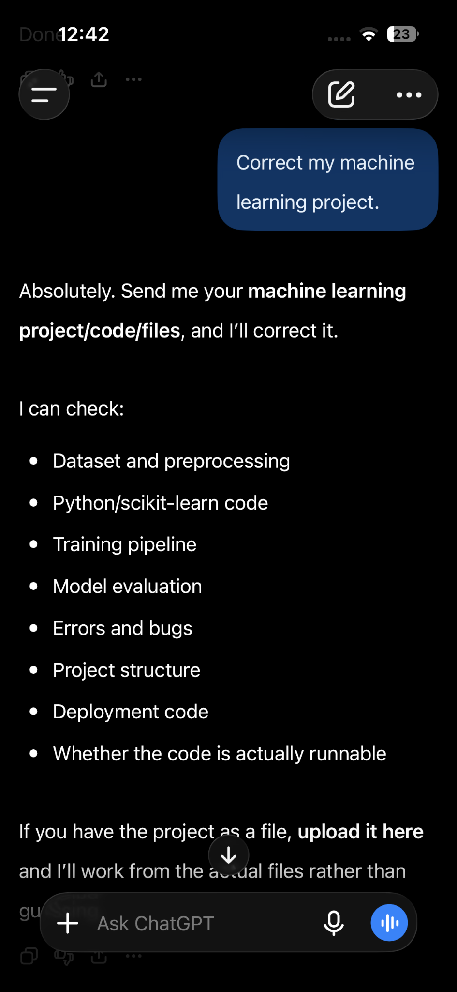 | After  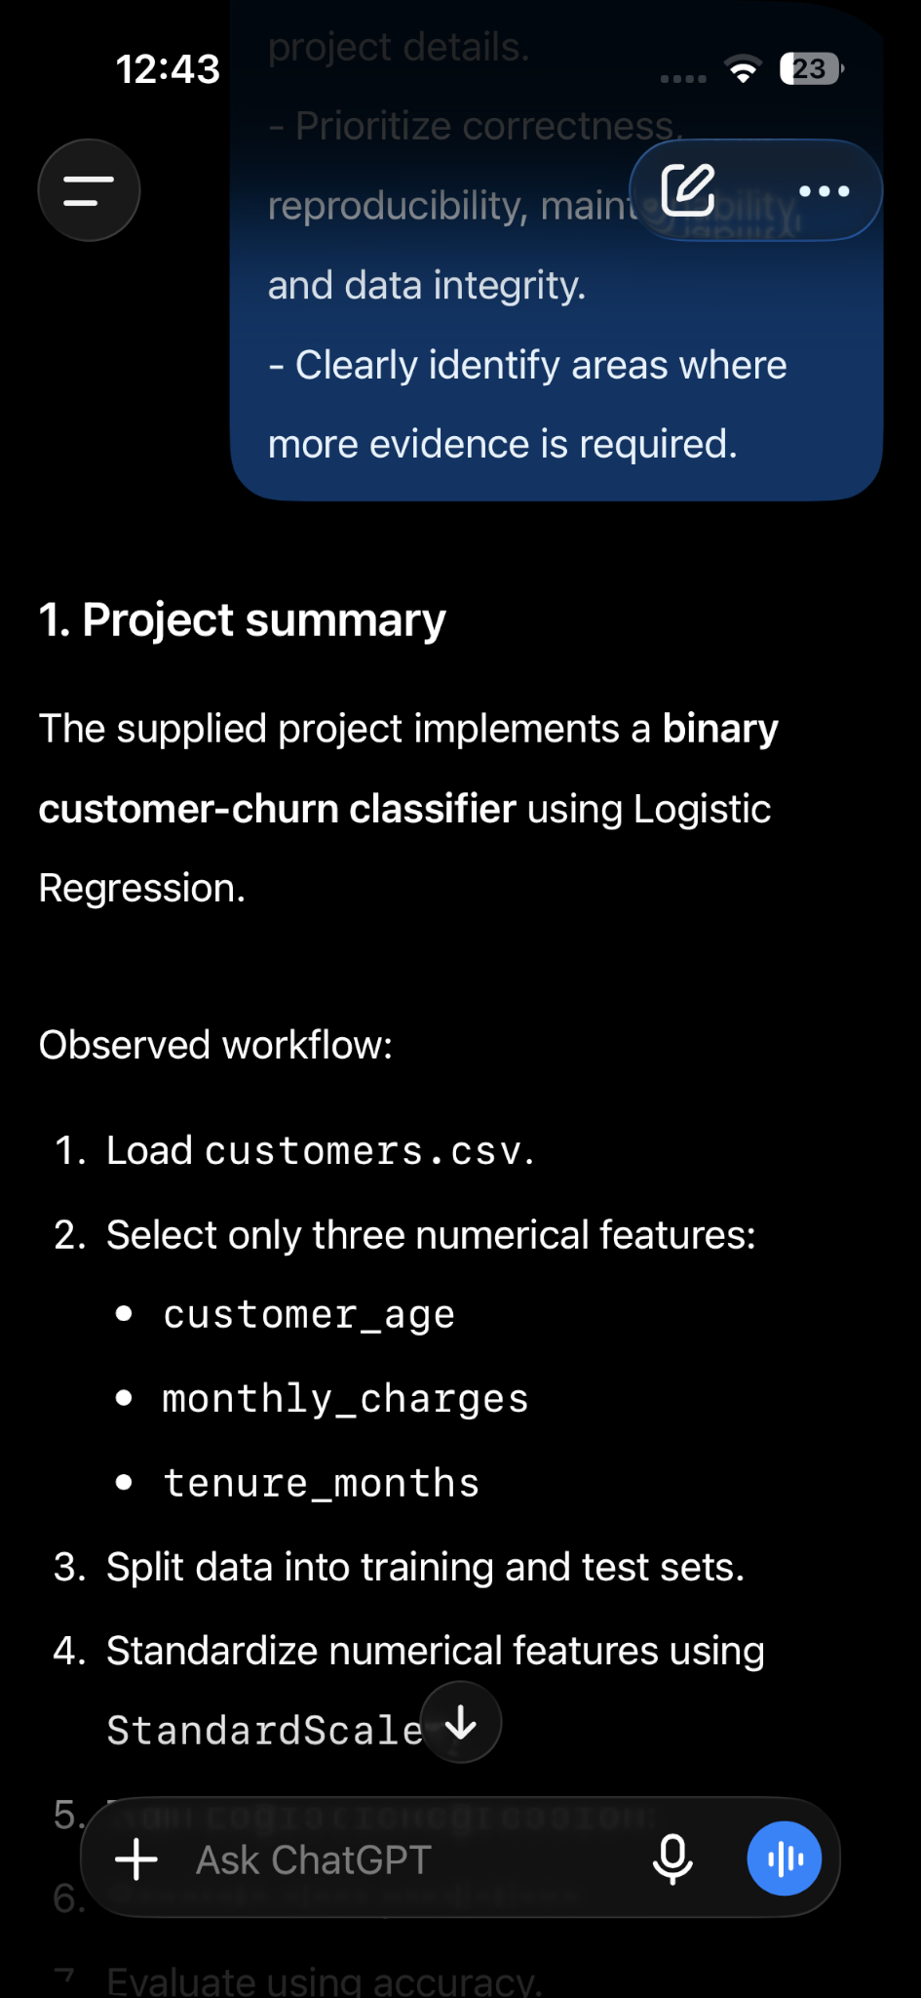
Comparison & Improvement Analysis
The improved prompt creates a repeatable review framework and prevents unsupported assumptions. It also separates observed issues from recommendations, making the review easier to act on.
Few-Shot Prompt Examples
The following prompt demonstrate how worked examples can guide the model toward a desired output or failed output
Improved — ML error classification
ROLE: Act as a machine-learning error-analysis assistant. TASK: Classify prediction errors using the examples below. EXAMPLE 1: Input: Actual=1, Predicted=0, Confidence=0.91
Category: High-confidence false negative EXAMPLE 2:
Input: Actual=0, Predicted=1, Confidence=0.62
Category: False positive NOW ANALYZE: Input: Actual=1, Predicted=0, Confidence=0.76 OUTPUT:
Error ID | Category | Reason | Confidence | Suggested investigation
Failure — Ambiguous ML Task
Test prompt: Build a model for my dataset. Diagnosis: The task does not identify classification, regression, target, success metric or dataset characteristics. Lesson: Provide the task type, target, relevant schema and evaluation objective.
Aproved  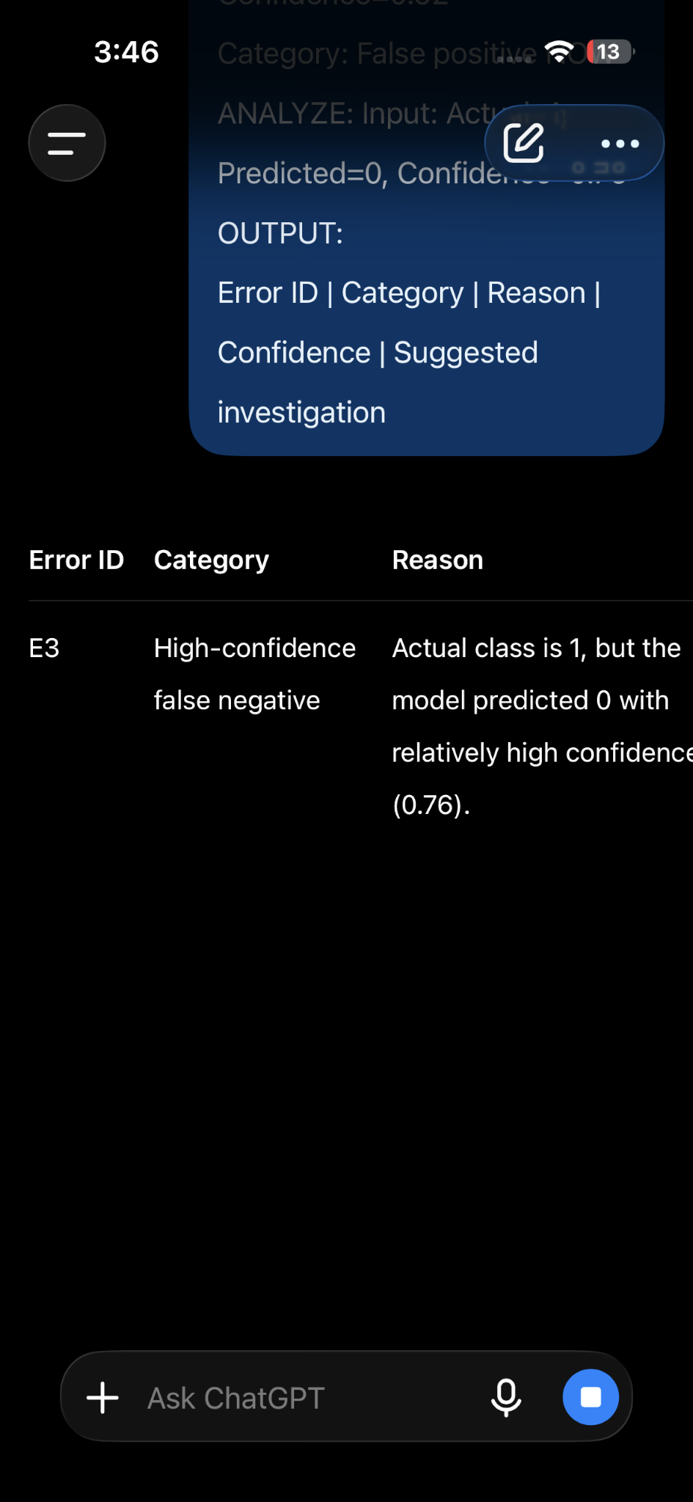 | Failed  